

Reserve Bank of India
Department of Statistics and Information Management
Mumbai

Frequently Asked Questions (FAQs) – 2 for Foreign Liabilities and Assets Information Reporting (FLAIR) – Online Web Based Reporting System

For General Instructions and Definitions, please go through FAQs-1 for FLA

Eligible Companies / Entities to Submit the FLA Return

Q 1. Which entities are required to submit the FLA Return?

Ans: The annual return on Foreign Liabilities and Assets (FLA) is required to be submitted by the following entities which have received FDI (foreign direct investment) and/or made FDI abroad (i.e. overseas investment) in the previous year(s) including the current year i.e. which have outstanding foreign assets or/and liabilities on their balance sheets;

- A Company within the meaning of section 1(4) of the Companies Act, 2013.
- A Limited Liability Partnership (LLP) registered under the Limited Liability Partnership Act, 2008
- Others [include SEBI registered Alternative Investment Funds (AIFs), Partnership Firms, Public Private Partnerships (PPP) etc.]

Q 2. How does the entity report data and submit the FLA return to the RBI?

Ans: All the steps, one by one for online web-based reporting of annual return on FLA, are provided in user manuals. Entity should read
(a) User manual on “FLA User Registration Form” and
(b) User manual on “Filling Online FLA Form”
for step-by-step guidance on procedure of registration on the portal and filing the FLA return.

FAQs Related to “FLA User Registration Form”

Q 3A. How can an entity submit online Annual Return on Foreign Liabilities and Assets (FLA Return)?
Ans: Entities can submit the online Annual Return on FLA through the online web-based portal having address https://flair.rbi.org.in
- To access the URL https://flair.rbi.org.in., any of the browsers viz; Internet Explorer, Google chrome, Firefox etc. can be used, as all of these would support this application.
- The entity has to register on the portal by clicking Registration for New Entity Users.
- The entity has to fill the details in the FLA user registration form, upload the documents mentioned (Verification Letter and Authority Letter) and click submit to complete the registration. After successful registration, user id and default password will be sent to the authorized person’s mail id. Using this user id and password, entity can login to the FLAIR portal and file the FLA Return.
- Please note: The format and email-based reporting system has been replaced by the web-based format for submission of annual FLA return from June 2019 (refer to circular Annual Reporting of Foreign Liabilities and Assets (FLA) –Move to FLAIR web-portal dated June 28, 2019 available on RBI website https://rbi.org.in).

Q 3B. How can an AIF (Alternative Investment Fund) file the FLA Return?
Ans: An AIF needs to register on the FLAIR portal. Since there is no provision for online filing of FLA return for AIF in the prescribed format, they need to send a mail to flareturn@rbi.org.in requesting for the form for filing of FLA Return for AIF after completing registration process on the portal. Thereafter FLA Team will send the excel form for filling FLA Return by AIF via mail to them. They need to fill the excel form and send us the same on flareturn@rbi.org.in. Email based acknowledgement form will be sent to them by FLA Team on receiving and validating the filled-in FLA form.
Q 4. When does an entity need to fill registration form?
Ans:
- If the entity is filing the FLA Returns for the first time.
- If the details of authorized person have changed during the latest financial year.
- If the Entity name/address has changed during the latest financial year.
- If Corporate Identification Number (CIN) / LLP Identification Number (LLPIN) / Others (UIN) / Partnership Firm - as on latest financial year ending March has changed from that of previous year

Q 5. What are the required documents for registering on the FLAIR portal?

Ans: Entities should keep the following details ready before they start filling the registration form. They can prepare the following table for convenience during the registration. Entities are advised to read all the FAQs carefully before filing the returns.

Field Name | Field Description | Please fill your relevant details here
ENTITY DETAILS
Entity Type* | Choose appropriate options, from the following:  - Company  - Limited Liability Partnership  - Others  - Partnership Firms
Corporate Identification Number (CIN) / LLP Identification Number (LLPIN) / Others (UIN) / Partnership Firm - as on latest financial year ending March* | Provide the appropriate details
Entity Name* | Enter entity name
PAN of the Entity* | Enter entity PAN Number
Registered address of the Entity* | Enter registered address of the entity
Email* | Enter email of the entity
Mobile number of the Entity* | Enter mobile number of the entity
State* | Select appropriate option from drop down menu
District* | Select appropriate option from drop down menu
Pin Code* | Enter PIN code of registered address of the entity
Whether the CIN / LLPIN / Others (UIN) of entity has changed during the latest financial year ending-March? * | Select Yes or No
- If Yes, Old CIN / LLPIN / SEBI registration no. of entity *  - Effective Date of Change* | If Yes is selected for the above question, these two questions will pop up. Please fill the Old CIN/LLPIN/SEBI registration no. of entity and select the effective date of change in information from the drop-down calendar.
Whether the Name of entity has Changed during the latest financial year ending-March? * | Select Yes or No
- If Yes, Old Name of entity*  - Effective Date of Change* | If Yes is selected for the above question, these two questions will pop up. Please fill the Old Entity name and select the effective date of change in information from the drop-down calendar.
AUTHORIZED PERSON'S DETAILS

First Name* | Enter Authorized person's first name
Middle Name | Enter Authorized person's middle name
Last Name* | Enter Authorized person's last name
User Name | Enter username the entity wants to use as login credential for FLAIR portal.
PAN no of Authorized person* | Enter Authorized person's PAN Number
Mobile number of Authorized person* | Enter Authorized person's mobile number
Email* | Enter Authorized person's email
Confirm Email* | Re-enter Authorized person's email entered above to confirm.
Please note, the fields marked * are mandatory.

Apart from the above details, the following documents are also to be uploaded:
- Verification letter: The soft copy of the verification letter (doc) is available on FLAIR portal; Companies/LLPs/Others are required to download the same and fill the required details and convert the same to PDF format. Thereafter .pdf file should be attached in User Registration Form by clicking ‘UPLOAD Verification Letter’ option. Further, entities are advised not to alter/change the verification letter format which is available on FLAIR portal.
- Authority letter: The soft copy of the authority letter (doc) is available on the FLAIR portal; companies/LLPs/Others are required to download the same and fill the required details and this authority letter has to be signed by concern authority and then after scanning the same; convert it to PDF format and thereafter .pdf file should be attached in User Registration Form by clicking ‘UPLOAD Authority Letter’ option.

Q 6. Who is an authorized person?
Ans:
- The person who is authorized by the entity to fill and manage FLA Returns is called an Authorized person.
- The Entity needs to furnish the details of its authorized person in the authority letter available on the FLAIR portal.
- Default password and OTP (every time, whenever the company logs-in to the FLAIR portal) is sent to the email of the authorized person furnished during registration.

Q 7. What is authority letter?
Ans:
- Authority Letter is used to furnish the details of the person who is authorised by the entity to fill and manage FLA returns.
- The format of the Authority letter is available on the FLAIR portal.
- The Authority Letter needs to be uploaded during the time of registration.

Q 8. What is verification letter?
Ans: Verification Letter is used to verify the details furnished by the entity while filling the registration form.

Q 9. What are the checks required for successful error free verification?
Ans: While doing the registration, the entity should ensure that the following details are same on the registration form (web page) and in the verification letter which is uploaded:
- PAN of authorized person
- Corporate Identification Number (CIN) / LLP Identification Number (LLPIN) / Others (UIN) / Partnership Firm - as on latest financial year ending March.
NOTE:
When the entity submits the registration form after filing all details and uploading the documents, the above details (mentioned in Q 8) will be auto checked by the system. If the details entered by the entity in the registration form (web page) matches with the details in verification/authority letter, then the registration gets successful. Otherwise, the system gives an error message saying ‘Details in registration form does not match with details in verification/authority letter’ and in that case the entity has to correct the details either in registration form or verification/authority letter and then submit the form for successful registration.

Q 10. What is relevance of username and email of authorised person in registration form?
Ans:
- The username becomes the login credential for logging into the FLAIR portal for the entity.
- Default login password and OTP (for every time login to the FLAIR portal) is sent to the email of the authorized person furnished during registration.

Q 11. Is an entity required to provide sign or seal of the signing authority in the authority letter?
Ans: The entity may use manually/scan or digital signature (of any person mentioned as authorized user/business user him/herself in the form) on authority letter.

Q 12. Where would I receive the login credentials for entity-user?

Ans: Login credentials would be received on the email-id of authorized person entered at the time of registration.

Q 13. What is the validity period of default password sent to the authorized person’s email?

Ans: This default password is valid for 24 hours after registration. You are required to change the default password by logging into the portal for the first time.

Q 14. What is the validity of the OTP sent to the authorized person’s email for login?

Ans: This OTP for login is valid for 5 minutes within which you need to login into the portal.

Q 15. I have registered as an entity-user but not yet received password to log-in the system. Why?

Ans:
- Please check your email inbox and check the junk mail folder. You should wait for some time.
- If you do not receive the password even after waiting for a sufficient time, check the blocking issue on your mail server and allow it to receive emails from RBI.
- In case still the issue persists, raise your issue by email to flareturn@rbi.org.in.

Q 16. What should I do if registration login page/ FLA online form hangs, and I couldn’t enter the details?

Ans:
- You are advised to keep the information and documents mentioned in Q 5 ready before you start filling the registration.
- If you do not enter any information for 15 minutes (i.e. if the registration page is kept idle for 15 minutes), it will hang your session. In that case refresh the page. If a message tells you that your session has timed out, simply log in again to continue.

Q 17. What if I do not receive my OTP / OTP gets delayed while filing the FLA form?
Ans:
- Wait for sometimes or retry for OTP by clicking resend OTP.
- Check the blocking issue on your mail server and allow it to receive mails from RBI.
- If the issue persists, raise your issue by mailing to flareturn@rbi.org.in.

Q 18. I entered the wrong password several (5) times and now I cannot login the FLA webpage, what should I do?
Ans: In case you enter the wrong password several (5) times, then you will receive the message “Your account is locked. Please retry after 15 minutes”. You need to wait for 15 minutes and then retry logging into the portal. If you are still unable to login, click ‘Forgot Password’ Menu available on the screen. Enter the details i.e., username, authorized person’s email ID and valid captcha code (Captcha is case-sensitive). Default password will be generated and same will be forwarded to the authorized person’s email ID. User should change the default password by logging into the portal after password reset. If user is unable to reset password, then he/she can mail to RBI at flareturn@rbi.org.in.
Q 19. What is the procedure to change the details of Authorized Person for FLA return submission?
Ans: Entity needs to send a request mail to RBI (flareturn@rbi.org.in) for deactivating the user, mentioning the entity Name, User Name and entity CIN/LLPIN/UIN in the mail. FLA support team will take necessary action regarding this. Once the account is deactivated, you can re-register as a new user.
Q 20. If an entity has forgotten their username and password, should they re-register on the portal?
Ans: No, the entity should raise their issue by sending an email to RBI (flareturn@rbi.org.in) mentioning the Company Name and Company CIN/LLPIN/UIN in that mail. FLA support team will provide the company with their username and authorized person’s email id which was used at the time of registration. They can reset the password thereafter.

Q 21. When should an entity raise a de-activation request?
Ans: Entities should raise deactivation request in the following cases:
- Change in authorized person’s details.
- Change in entity name/address.

Q 22. What needs to be mentioned under Unique Identification Number (UIN) for AIF at the time of FLA user registration?
Ans: AIF should use the Registration Number given by SEBI at the time of registration as the UIN for registering on the FLAIR portal.

Q 23. Is an AIF registered as Trust, required to file FLA return? If yes whether single FLA return to be filed for the AIF or separate FLA return to be filed for each scheme under the AIF?

Ans: Yes, the AIF should file a combined FLA Return.

Section-wise FAQs
FAQs Related to Section I
Q 24. I am not able to furnish information in Identification Details for “Name of the Indian entity”, “PAN Number”, “CIN Number” and “Email (Head of institution)”?

Ans:
- In Section – I, above mentioned fields namely, “Name of the Indian entity”, “PAN Number”, “CIN Number” and “Email (Head of institution)” are automatically filled based on the information furnished by the entity during registration. You need not enter those fields.
- In case these details have changed after the registration process, the entity needs to deactivate the old account and re-register on the portal with new details.

Q 25. Who is the contact person?

Ans: The contact person is a person appointed by the entity with whom RBI can communicate in case any data inconsistencies are found in the filed FLA Return. The contact person can be same as the authorized person whose details are furnished in the Authority letter at the time of registration.

Q 26. What numbers should an entity use to file the FLA returns if the account closing date is different from 31st March of the respective year?

Ans: If reporting period is different from Account Closing Period, then information should be given based on internal assessment of the entity. Also note that, information should be created for both the reference period i.e., previous March and latest March.

Q 27. Where can we find the detailed description of NIC-2025 code (item-6)?

Ans: In the FLA Return, industry codes are given as per the National Industrial Classification (NIC) -2025 codes. The details on NIC-2025 codes can be accessed through the following link,
https://www.mospi.gov.in/uploads/publications_reports/publications_reports1763457214315_c3e5d4f3-8e25-4775-85e3-ad42d571652f_NIC_2025_Final.pdf

Q 28. If an entity has more than one activity during the year, then which NIC code should be reported by entity (item-6)?

Ans: Entity can select that activity, from which they have earned majority revenue.

Q 29. What are classes/types that an entity may have?

Ans:
- Classes/types relates to number of different face values the entity may have. For example, Ordinary/equity/participatory/Non-participatory preference shares may have one/two (or more) different classes of face values. (Illustration: if a company has shares of face values say, INR 10 and INR 20, then “2” should be entered).
- Please note, if classes/type is more than 1 in any of the year (PY/CY), then in Section II you need to enter INR lakh value manually.
- If there is no face value, “0” should be entered.
- The above details are to be furnished in the block whose screenshot is given below.

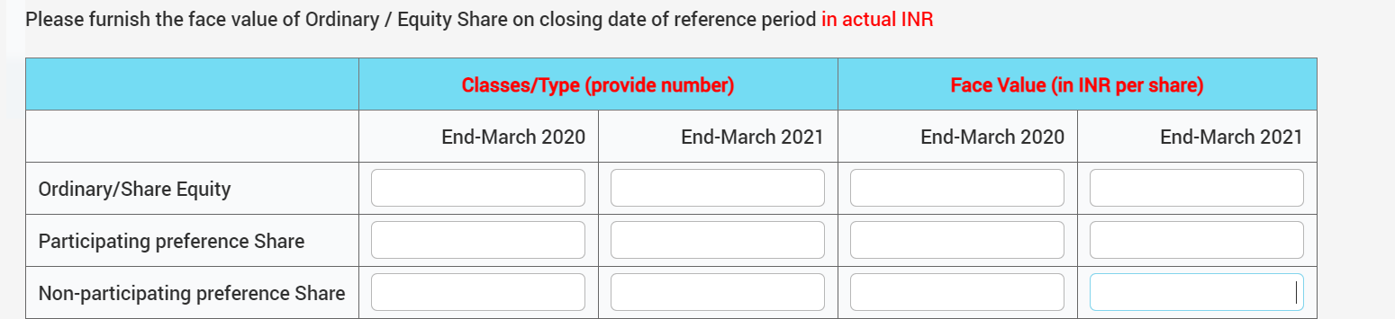

Right Classes/Type reporting:
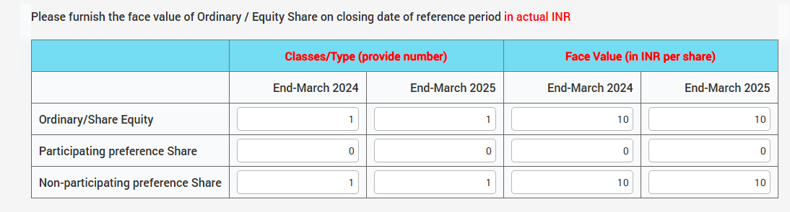

Wrong Reporting:
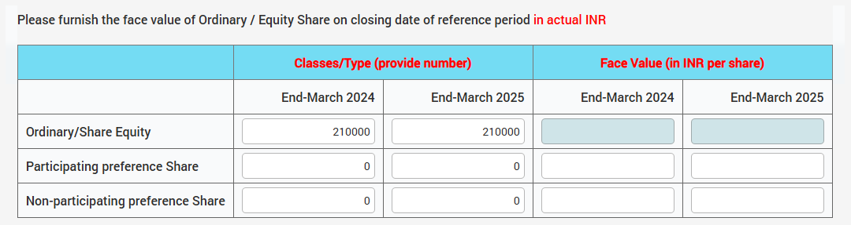

Q 30. What is the identification of the reporting entity (in terms of inward FDI) stated in item no 9 of Section-I?

Ans:
- If an entity has inward FDI, select an appropriate option from the following :
  - Associate of Foreign Entity (If single foreign investor holds between 10% and 50% of equity shares).
  - Subsidiary of Foreign Entity (If single foreign investor holds more than 50% of equity).
- If an entity has only Outward Investment and no inward FDI then “Others” should be selected.
- If an entity is LLP, “Limited Liability Partnership” should be selected.

Q 31. What is the meaning of Foreign Technical Collaboration (item-11)?

Ans: An Indian entity which has entered into an agreement with a foreign entity in terms of technology transfer, know-how transfer, use of patent, brand name etc., then such type of agreements is treated as Foreign Technical Collaboration (FTC). If Indian reporting entity has such type of FTC during the reporting period, then it should select ‘Yes’ against the item 11 under Section I of the FLA return.

Q 32. Our Entity Name has changed. Since this is auto populated in Section I, how can I change the same?

Ans: You need to deactivate the account on FLAIR portal with old Entity Name. For account deactivation, raise a request with RBI by writing a deactivation request mail to flareturn@rbi.org.in. Please mention the old name of the entity, CIN/LLPIN/UIN and username in the e-mail. Once RBI confirms the deactivation of your account, you can re-register in the portal with new details.

Q 33. Our Head of the Institution has changed. How can we change this details in Section I?

Ans: You need to deactivate the old account on FLAIR portal. For account deactivation, raise a request with RBI by writing a deactivation request mail to flareturn@rbi.org.in. Please mention the entity Name, CIN/LLPIN/UIN and username in the same mail. Once RBI confirms the deactivation of your account, you can re-register in the portal with new details.

Q 34. In case we re-register on the portal, how will we get the filled documents of earlier FLA Returns?

Ans: The old FLA Return will be linked with the new account if the CIN/LLPIN/UIN used in both the registrations are same. In case there is a change in CIN/LLPIN/UIN and the entity re-registers on the portal with new details, there is no provision to link the old account to the newly created one.

FAQs Related to Section II

Q 35. How is Section II, item 1.0, i.e., Total Paid-Up Capital calculated?

Ans: The Total Paid-Up Capital is calculated using the following formula:
Total Paid-Up Capital1.0 = 1.1+1.2
where,
1.1 = Total Equity and Participating preference share capital = 1.1(a)+1.1(b)
1.1 (a) = Ordinary/Equity Share
1.1(b) = Participating preference share
1.2 = Non-Participating Preference Share

Q 36. I am unable to enter the paid-up capital of the entity in item 1.0 of Section II. What should I do?
Ans: Paid up capital is automatically calculated with the help of your inputs given in 1.1(a), 1.1(b) and 1.2. Please note, the formula used for calculating the paid-up capital is given in Q35.

Q 37. In Section II, item 2.3, how is, Non-Resident Equity and Participating Preference Shares Capital % calculated?

Ans: The Non-Resident Equity and Participating Preference Shares Capital % is calculated using the following formula:

Non-Resident Equity and Participating Preference Shares Capital %
Item 2.3 = $\frac{Item 2.1}{Item 1.1}$*100

where,
2.1 = Equity and Participating Preference Share Capital = 2.1.1+2.1.2+2.2
2.1.1 = Equity share capital = Sum of item 1-12 under the 2.1.1 block
2.1.2 = Participating Preference share capital = Sum of item 1-12 under the 2.1.2
2.2 = Non-Participating Preference Share
1.1 = Total Equity and Participating Preference Share Capital

Q 38. Whether, in Section II- Item 2.3, the Non-Resident Equity and Participating Preference Shares Capital (%) is being calculated with respect to Item 1.0 (Total Paid-up capital) or Item 1.1 (Total Equity and participating Preference Shares Capital)?

Ans: Since Non-Participating preference share capital is a type of debt investment and is part of Item 1.0, Non-Resident Equity and participating Preference Shares Capital (%) is calculated with respect to item 1.1 (of Section II) and not 1.0. The formula for calculating the same is indicated in Q37.

Q 39. In the Section II Block 2 of FLA form, what should I take for convertible preference share?
Ans.: You should take fully diluted preference share.

Q 40. Item number 3, 4, 5 of Section-II, should be reported in INR LAKH. How to report in INR LAKH?

Ans: Reporting in INR lakh means, if you want to report Rs.1,50,000 for some item, you should write 1.5 and not 150000. That is, it represents amount in Indian Rupee in Lakhs.

Q 41. Where should we report the premium on issue of Equity Share Capital?
Ans: Premium on issue of Equity Share Capital is a part of Reserve, which should be reported under the item 4.1 - Reserves and Surplus, (in Section II).

Q 42. What should we include in item 5, Sales and Purchase (in Section II)?

Ans: The entity needs to report the sales/earnings which is generated as part of the regular business activity/purpose only. That is revenue from operations (i.e., sale of goods and services). However, if the primary revenue of the reporting entity is from interest/commission/foreign exchange or revaluation gain, example for hiring/leasing/money changing entities, etc., they need to be reported, being the primary revenue from operations.

FAQs Related to Section III

Q 43. What is meant by “Month and Year of receiving FDI first time in our Company/LLP/Others”?

Ans: Entities are required to provide the month and year of receiving FDI first time irrespective of number of investors reported.

Q 44. What is “Edit / View / Delete FDI (DI) Details” details in section III, item no. 1.b FDI and 2.b DI?

Ans: While filling section III, in 1.b / 2.b, non-resident investor details / non-resident investor countries’ details will be displayed as pre-filled (for the companies which have reported FLA- for previous year(s)) and by clicking on Edit/Delete button companies will be able to modify the non-resident investor details (companies will be able to choose to add new investor/ delete existing investors). For new companies (who have not reported FLA for previous year(s)), details related to non-resident investors has to be entered by the entity.
Please Note: For existing non-resident investor / non-resident investor countries’, the entity needs to use edit button and fill the details for previous year and current year and save/add FDI/DI button.
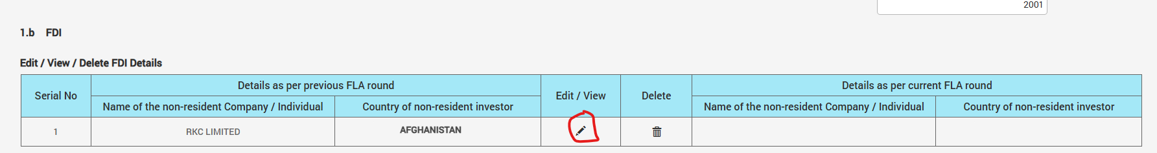

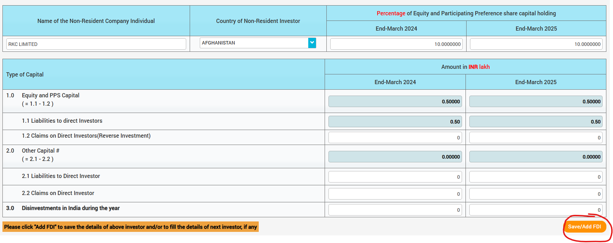
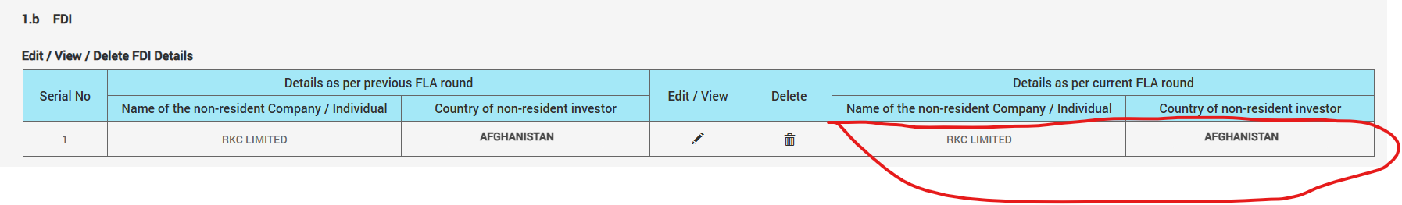

2. If the existing non-resident investor change their holding (from FDI (more than 10%) to DI (less than 10% or DI to FDI), then the entity needs to delete the existing data for those investors and fill in appropriate tab (as per revised holding).

Please see the following screenshots to understand the step.

i) First delete the existing non-resident investor details by clicking the delete button.

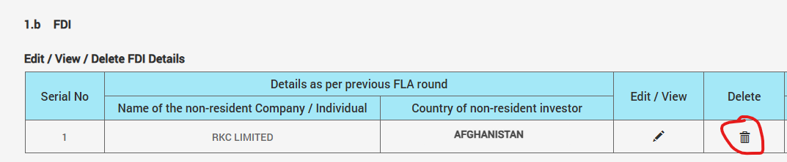

ii) Write delete remarks and approve.

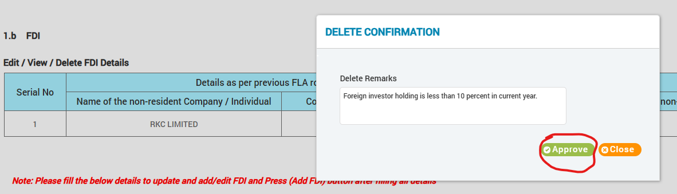

iii) Add the details of non-resident under 2.b of Section-III (DI Less than 10%) and save.
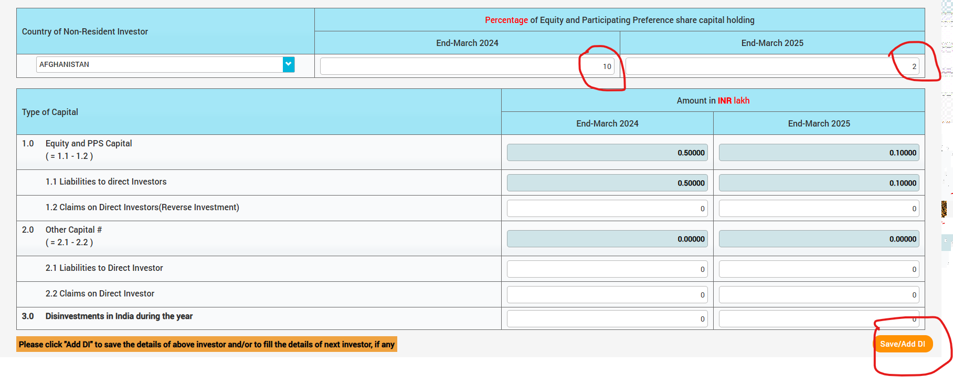

iv) After save/Add DI, the details of country of non-resident will displayed.
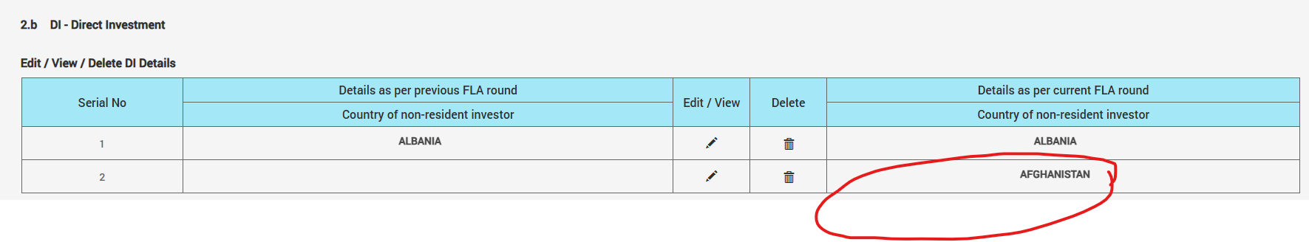

Q 45. What is Save/Add FDI (DI) in Section III, item 1.b FDI and 2.b DI?

Ans: In case the entity is filing the FLA Return for the first time or new FDI/DI has been received, then the details corresponding to that needs to be entered in the Block 1.b for FDI and 2.b DI. Thereafter the Save/Add FDI (DI) button given below the block needs to be clicked, so that the required details are added to the form. If this button is not clicked, then information corresponding to the new FDI/DI will not be added and hence will not be considered by the system during the validation process of Section III.

Q 46. In Section III Block 1 of FLA form, which will be the date of first receipt of FDI received?
Ans: This may be taken as Settlement date/allotment date

Q 47. What is meant by “Disinvestments in India during the year” / “Disinvestments abroad during the year”?

Ans: Any disinvestments made by non-resident direct investor of the reporting Indian entity during the year should be reported in section III item 3.0 (all blocks). Likewise, any disinvestment made by the reporting Indian entity in its DIE abroad during the year should be reported in section IV item 3.0 (all blocks). Please refer Q 44 for disinvestment process.

Q 48. Where should we report the non-participating preference share issued to non-resident?

Ans: Non-participating preference shares are treated as debt securities. (a) If the Non-participating preference shares are held by foreign investor who is also holding equity shares of Indian reporting entity, then non-participating preference share should be reported in item 2.1 of 1.b FDI and 2.b DI in Section III (depending upon the % equity & participating preference share held by foreign investor) at nominal value.

Q 49. Where should we report Fully/Partially/Non-convertible debentures issued to the non-residents in FLA Return?

Ans: Fully/Partially/Non-convertible debentures are treated as debt securities. (a) If the debentures (of any type) are held by foreign investor, the amount should be reported at item 2.1 of 1.b FDI and 2.b DI in Section III (depending upon the % equity plus participating preference share held by foreign investor) at nominal value.

Q 50. What treatment should be given to share application money received from non-resident investor?

Ans: If the share application money is received from the existing non-resident shareholder, then the outstanding share application money should be reported at item 2.1 of 1.b FDI and 2.b DI in Section III, depending upon per cent of equity plus participating preference share holding by non-resident investor.
Further, if the share application money is received from foreign investor who does not hold equity shares of Indian reporting company as on reference date, then outstanding share application money should be disclosed under this item 4 – ‘Other Investment in Other receivable and payable accounts’.

Q 51. On validating section III of the FLA Return we are getting the error message regarding mismatch of non-resident equity and participating preference share holding (%) between Section III and Section II. How should we resolve the error?

Ans: Non-resident equity holding per cent (%) is calculated for current year at item 2.3 under Section II. Ensure that the sum of Non-resident equity holding per cent (%) reported under 1.b FDI, 2.b DI and 3 (for current year) of Section III must be equal to value given in item 2.3 (for current year) of Section II.

Q 52. What constitute in the Equity Securities under portfolio Investment (3 of Section III)?

Ans: Please furnish here the outstanding equity investments (secondary / stock market investment) by non-resident investors, other than those made under Foreign Direct Investment Scheme in India (i.e. other than those reported in 1.b FDI and 2.b DI of section III).

Q 53. What constitute in the Debt Securities under portfolio Investment?

Ans: Following items are included in Debt Securities:
- Money Market Instruments and Bonds & Other instruments hold by non-resident investors, (other than those which are reported in 1.b FDI and 2.b DI of section III)
- Non-participating preference shares and debentures are held by foreign investor who is not holding equity share, then the same should be reported at item 2.2 of point 3 in section III (Bonds & Notes) at nominal value.

Q 54. In case of item 4. Other Investment (section III), it is written that outstanding liabilities with foreign unrelated parties to be given. Please clarify what foreign liabilities are to be reported under the same?

Ans: All financial outstanding liabilities (Trade Credit, Loans, Currency & Deposits, and other receivable & payable accounts) with foreign unrelated parties should be reported here. Any domestic liabilities (even if it is in foreign currency) should not be reported in the FLA return.
Further, if the share application money is received from foreign investor who does not hold equity shares of Indian reporting company as on reference date, then outstanding share application money should be disclosed under this item 4 ‘Other Investment in Other receivable and payable accounts’.

Q 55. Will the balances under the EEFC account with Bank, covered under item 4. Other Investment of section III (Currency and Deposits)?

Ans: Balance under the EEFC account with Bank is not creating any external Assets and Liabilities. Therefore, it will not come under this field.

Q 56. Whether any domestic assets or liabilities for Indian party are to be included in the FLA Return?

Ans: Any domestic liabilities or assets (even if it is in foreign currency) should not be reported in the FLA return.

FAQs Related to Section IV

Q 57. What exactly is the meaning of 1.b ODI in Section IV under Foreign assets?

Ans: 1.b ODI of Section IV on foreign assets captures the information on financial details of Overseas Company in which your company’s equity holding is 10 per cent or more.

Q 58. If the overseas subsidiaries/ joint venture company’s accounting period is different from the reference/reporting period (i.e., April-March) in the FLA Return, then what information should we furnished in Section IV?

Ans: Companies are required to furnish the information on outstanding external liabilities and assets as on end-March of previous and current year. In case if the accounting period of overseas subsidiaries/ joint venture of Indian reporting entity is different from the reference period, then the information for end-March should be given on internal assessment basis.

Q 59. What is “Edit / View / Delete ODI(DI)” details in Section IV, item no. 1.b ODI and 2.b DI?

Ans: While filing section IV, in 1.b / 2.b, DIE details / DIE countries’ details will be displayed as pre-filled (for the companies which have reported FLA- for previous year) and by clicking on Edit/Delete button companies will be able to modify the DIE details (companies will be able to choose to add new DIE/ delete existing investors). For new companies (which has not reported FLA-for previous year), those details related to DIE has to be entered by company.
Step-by-step details are same as given in Q 44 of this document.

Q 60. What is Save/Add ODI(DI/PI) in Section IV, item 1.b FDI, 2.b DI and 3.b PI?

Ans: In case the entity is filing the FLA Return for the first time or new ODI/DI/PI has been received, then the details corresponding to that needs to be entered in the Block 1.b for ODI, 2.b for DI and 3 for PI. Thereafter the Save/Add ODI(DI/PI) button given below the block needs to be clicked, so that the required details are added to the form. If this button is not clicked, then information corresponding to the new ODI/DI/PI will not be added and hence will not be considered by the system during the validation process of Section IV.

Q 61. What information should we report in item 3.7, item 3.7.1, item 3.8, item 3.8.1 in Section IV?

Ans: The entity needs to report the sales/earnings which is generated as part of the regular business activity/purpose only. That is revenue from operations (i.e., sale of goods and services). However, if the primary revenue of the reporting entity is from interest/commission/foreign exchange or revaluation gain, example for hiring/leasing/money changing entities, etc., they need to be reported, being the primary revenue from operations.

Q 62. In case where overseas company (DIE) is unlisted, how can we calculate the market value of overseas equity investment using OFBV method under 1.b ODI of Section IV?

Ans: For valuation of overseas equity investment OFBV Method should be used, as explained below:
OFBV Method:

Market value of equity capital held by you at OFBV for unlisted companies
= (Net worth of the DIE) * (% of equity held by you)
where,
Net worth of the DIE = Paid up Equity & Participating Preference share capital of company +Reserves & Surplus - Accumulated losses (which is automatically calculated in item 3.5 in 1.b ODI).

As per 1.b ODI of Section IV the formula is given below:
Item 1.1 Claims on Direct Investment Enterprise = (Item 3.3/ Item 3.2) * (Item 3.5* Item 3.6) /100000 for reference period
where,
Item 3.2, Item 3.3, Item 3.5 and Item 3.6 are extracted from 1.b ODI.

Q 63. How will we do the valuation of the equity capital for listed DIE?

Ans: If the overseas company is listed then closing share price as on reference period, i.e., end-March of previous and latest year should be used for valuation of equity investment.

Q 64. What constitute in the Equity Securities under block 3, PI-Portfolio Investment Abroad in Section IV?

Ans: Please furnish here the outstanding equity investments (foreign stock market investment) by reporting entity, other than those made under Foreign Direct Investment Abroad (i.e., other than those reported in 1.b ODI and 2.b DI of section IV).

Q 65. What constitute the Debt Securities under Portfolio Investment Abroad, Section IV?

Ans: Money Market Instruments and Bonds & Other instruments invested by reporting entity (other than those reported in 1.b ODI and 2.b DI of Section IV) are included in the Debt Securities under Portfolio Investment Abroad.

Q 66. In case of point 4. Other Investments (Section IV), it is written that outstanding claims on foreign unrelated parties to be given. Please clarify what transactions are to be reported under the same?

Ans: All financial outstanding assets (Trade Credit, Loans, Currency & Deposits, and other receivable & payable accounts) with foreign unrelated Parties should be reported here. Any domestic assets should not be reported here.

FAQs Related to Section V

Q 67. I have observed that I have entered wrong data in one Section of the FLA Form that I have filled. How can I modify my inputs?
Ans: Please click on the corresponding Section link available in the Description of item column in the variation report table where you have observed an error. It will re-direct you to the corresponding Section. Make the necessary changes and validate your inputs with the validate Section button present on the top right corner of the screen. Once all the inputs are correct, select Yes button in the last column, for all the row in the variation report table. Confirm the declaration provided and submit the FLA form to RBI.

Q 68. How would I get a copy of the FLA Form I have submitted to RBI?

Ans: You will receive a link to download the FLA Form on the screen, after it is submitted to RBI. Click on the link to download the FLA Form in .pdf format. Moreover, these forms can be downloaded in .pdf format later on from the portal by following the below given path:

Login to the portal Click on MENU tab on the top-left corner of the screenONLINE FLA FORM-REPORT-Select the appropriate year from the drop-down list-Click “Search” button-Click on the download link that pops up on the screen.

Q 69. How would an acknowledgement be provided to us on submission of the form?

Ans: You will receive a link to download the system-generated acknowledgement form on the screen, after the FLA Form is submitted to RBI. No separate mail will be sent in this regard. Moreover, please note that the acknowledgement form is system generated and is not stored by RBI. However, if the entity has not received the acknowledgement after filing the FLA return, then the entity needs to send an email to flareturn@rbi.org.in for confirmation of FLA return submission. A confirmation email from the flareturn@rbi.org.in will be treated as acknowledgement of FLA return filing.

